03/02/16
Shell Speed vs. Oar Blade Surface Area
.o0|0o.
According to ROWING model results it seems there is an advantage to be gained through the use of blades with grater surface area. Here are the results of a comparison between the recently introduced Bantam Compact (small) blade and its larger cousin, the Fat2 — both by Concept2.
The two blades are compared — most importantly — at equal rower total power, and simultaneously at equal lever ratio, and equal peak draw pull.
For simplification in the examples run the half-spread is kept equal to the inboard; thus the handle center-of-force is always at the shell centerline when the oars are at 90 degrees.
In the model (ROWING) speed comparisons are made for several ratings (from 28.0 to 36.0 1/min base).
In the comparisons the following variables are held constant:
o Shell characteristics
o Rower weight, height, and slide excursion
o Peak oar handle pull and force profile (the rower is never pulling more or less "hard"); however, he may be pulling slightly longer, but not as often.
o Length of the rower’s (longitudinal) draw from catch to release (catch and release angles vary)
o Total overall rower power(W) is achieved by adjustments in rating.
In other words, everything is held constant but the variables of interest; something that is possible only in a computer model such as ROWING.

The surface area of the Compact blade is 625 cm^2, and of the Fat2 blade 856 cm^2 (both figures from Concept2).

The result (Figure 1) indicates that the larger blade is the faster, and more efficient, owing largely to smaller absolute (wasteful) blade slip. Because the slip is larger the small blade will feel less “heavy”. The larger blade has also a greater shell advance per sweep.

Because the small blade uses less power at the same rating than the larger blade, equal total rower power requires a corresponding increase in its rating.

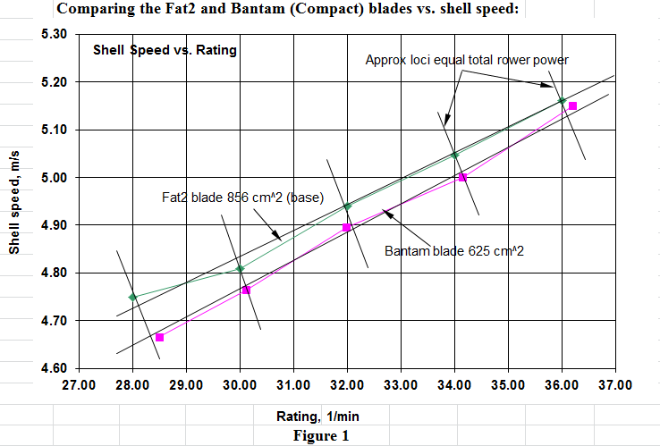
The average course time advantage for the Fat2 blade is 4.0 sec/2,000m:

Time advantage for 2,000m:
Fat2 rating, 1/min 28.00 30.00 32.00 34.00 36.00
Fat2 shell speed, m/s 4.75 4.81 4.94 5.05 5.16 Bantam rating, 1/min 28.50 30.12 31.98 34.14 36.20
Bantam shell speed 4.67 4.77 4.90 5.00 5.15
Advantage re base, s -7.58 -3.93 -3.64 -3.72 -0.90 -4 sec/2000m avg.

The complete program input and output data (including Figure 1) can be found in file Fat2vsBantam.xls.

.o0|0o.

